Contributor: Sara Stigberg

**Martins, Maria**

Born: Campanha, Minas Gerais, Brazil, 1894; Died: Rio de Janeiro, 1973

Maria Martins was a Brazilian sculptor and writer, a founding member of the *Fundação do Museu de Arte Moderna do Rio de Janeiro*, and a co-founder and exhibitor for the ***Bienal Internacional de São Paulo***. She made a name for herself in the international art world of the 1940s as “the sculptor of the tropics” and “the great sculptor of Surrealism,” though she was largely overlooked between the 1950s and early 2000s. The wife of a diplomat, in the art world she preferred simply to be known as “Maria.” She was influenced by **Jacques Lipchitz**, who encouraged exploration of her Brazilian identity in her work, and by **Surrealism**. A member of the expatriate artists’ community in New York, she was championed on the international stage by **André Breton** and held a long affair with **Marcel Duchamp**. Martins’ sculpture, based on natural forms and reflecting deep introspection, became increasingly abstract over the course of her career. On returning to Brazil from the U.S. in 1949, despite her standing abroad, Brazilian critics rejected her work for its non-traditional and eroticized manner and themes. Nonetheless Maria used her international connections in the art world to promote modern art in Brazil until her death.

Born to a prominent family, Maria Martins, or simply “Maria” as she preferred to be known artistically, studied at the *Escola Nacional de Belas Artes* in Rio de Janeiro. While accompanying her diplomat husband and their family to posts in Ecuador, France, Japan, Belgium, and the U.S. she continued her studies in music and painting with private teachers in Paris, and with **Oscar Jesper** in Belgium. In 1939 in Washington, D.C., Maria began to focus on sculpture; her first solo exhibition was held there in 1941. Over the next decade, Maria commuted between Washington and New York, where she became involved with the expatriate artists’ community, and was influenced by the surrealists; **André Breton** was Maria’s foremost promoter. Also around this time she began a lengthy affair with **Marcel Duchamp**.

In 1942 Maria mastered bronze sculpting under **Jacques Lipchitz**, who also encouraged her to explore Brazilian mythology as a subject. By 1943, Maria’s style, preferred medium (bronze), and her identity as the “sculptor of the tropics” were firmly established.

Maria’s sculpture, described variously as rhythmic, sensual, expressive, contorted, and violent, was based on natural forms; her manner became increasingly abstract over the course of her career. Subjects and themes of her work include Christian figures, Brazilian mythology, personal introspection, and interpersonal relations. Between 1944 and 1949 she executed several versions of her best-known work, *Impossible*, which portrays a male and a female figure frozen in dynamic intellectual and erotic opposition.

On returning to Brazil in 1949, despite her international reputation, Maria’s work was denigrated and rejected by Brazilian critics for its non-traditional aesthetic and eroticized subject matter. Nonetheless, for the rest of her life she used her connections to continue exhibiting and promoting modern art in Brazil.

In the mid-1950s Maria’s sculptural production decreased, and she focused more on travel and writing. Though still active in the art world, Maria was no longer sculpting when she died in 1973.

*Image*

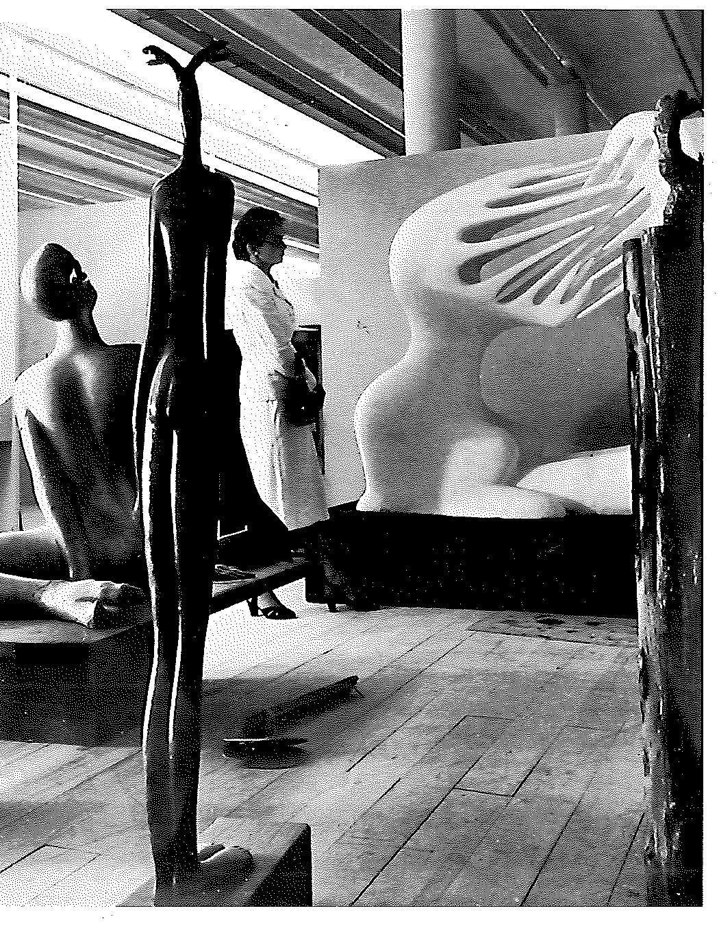

Sculptures by Maria in the first Bienal of São Paulo (and Maria), 1951

-- in Martins, M. (1998). *Maria: the surrealist sculpture of Maria Martins*. New York, André Emmerich Gallery.)

**References and Further Reading:**

Martins, M. (1998). *Maria: the surrealist sculpture of Maria Martins*. New York, André Emmerich Gallery.

Martins, M., Mello, V. D., & Cosac, C. (2010). *Maria*. [Washington, DC], McKinsey & Company.

Ramos, G., & Martins, M. (2009). *Maria Martins: escultora dos trópicos*. Rio de Janeiro, Artviva. (includes English translation)

**List of Works (selected):**

1. 1. Salome, 1938
2. 2. Yara, 1941
3. 3. Don’t Forget I Come from the Tropics, 1942
4. 4. *Sem Eco*/Without Echo, 1943
5. 5. Impossible, 1944
6. 6. The Road; The Shadow; Too Long, Too Narrow, 1946
7. 7. *Canto do Mar*/The Song of the Sea, 1952

8. *Ritmo do Ritmo*/The Rite of Rhythm, 1959